**Data Manipulation Language**

**Aim:**

To study about “Data Manipulation Language” commands in Mysql.

**SYSTEM REQUIREMENT:**

* Hardware: PC
* Software: Xampp

The DML commands in Structured Query Language change the data present in the SQL database. We can easily access, store, modify, update and delete the existing records from the database using DML commands.

**Following are the four main DML commands in SQL:**

1. SELECT Command
2. INSERT Command
3. UPDATE Command
4. DELETE Command
5. **SELECT COMMAND:**

* **SELECT command** is used to retrieve data from the database.
* This command allows database users to retrieve the specific information they desire from an operational database.
* It returns a result set of records from one or more tables.

**SELECT Command has many optional clauses are as stated below:**

| Clause | Description |
| --- | --- |
| WHERE | It specifies which rows to retrieve. |
| GROUP BY | It is used to arrange the data into groups. |
| HAVING | It selects among the groups defined by the GROUP BY clause. |
| ORDER BY | It specifies an order in which to return the rows. |
| AS | It provides an alias which can be used to temporarily rename tables or columns. |

1. **INSERT COMMAND:**

* **INSERT command** is used for inserting a data into a table.
* Using this command, you can add one or more records to any single table in a database.
* It is also used to add records to an existing code.

**Syntax:**

INSERT INTO <table_name> (`column_name1` <datatype>, `column_name2` <datatype>,`column_name_n` <database>) VALUES (`value1`, `value2`, . . . , `value n`);

1. **UPDATE COMMAND:**

* **UPDATE command** is used to modify the records present in existing table.
* This command updates existing data within a table.
* It changes the data of one or more records in a table.

**Syntax:**  
UPDATE <table_name> SET <column_name = value> WHERE condition;

1. **DELETE COMMAND:**

* **DELETE command** is used to delete some or all records from the existing table.
* It deletes all the records from a table.

**Syntax:**

DELETE FROM <table_name> WHERE <condition>;

**Queries:**

**Create:**

create table Student(Sname varchar(20), Srno integer, Sbranch varchar(20), Sgrade integer, Splace varchar(20));

Query OK, 0 rows affected (0.404 sec)

**Insert Query1:**

insert into Student values ('Sachin', 10, 'Mech', 100, 'Mumbai');

Query OK, 1 row affected (0.146 sec)

insert into Student values ('Rahul', 39, 'EEE', 97, 'Bangalore'),('Mahi', 10, 'CSE', 96, 'Ranchi');

Query OK, 2 rows affected (0.068 sec)

Records: 2 Duplicates: 0 Warnings: 0

**Select Query1:**

select * from Student;

MariaDB [sathyabama]> select * from Student;

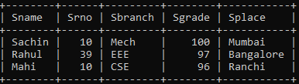

3 rows in set (0.001 sec)

**Select Query2:**

select Sname, Sbranch from Student;

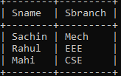

3 rows in set (0.001 sec)

**Select Query3:**

Select * from Student where Srno=10;

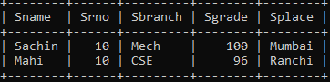

2 rows in set (0.001 sec)

**Insert Query2:**

insert into Student (Sname, Srno, Sbranch, Sgrade, Splace) values ('Raina', 48, 'CSE', 88, 'Punjab');

Query OK, 1 row affected (0.086 sec)

Select * from Student;

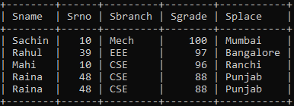

5 rows in set (0.001 sec)

**Update Query1:**

update Student set Sname='Kohli', Srno=19, Sbranch='Mech', Sgrade=99, Splace='Mumbai' where Splace='Punjab';

Query OK, 2 rows affected (0.142 sec)

Rows matched: 2 Changed: 2 Warnings: 0

Select * from Student;

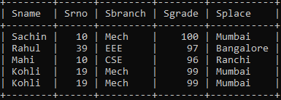

5 rows in set (0.001 sec)

**Delete Query1:**

delete from Student where Sname = ‘Kohli’;

Query OK, 2 rows affected (0.058 sec)

MariaDB [sathyabama]> Select * from student;

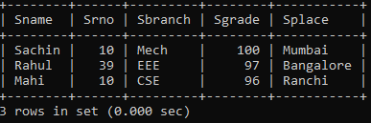

**Results:**

Hence the Data Manipulation Language commands are successfully executed.